Apr 3, 2026
ROPA UPDATE - NOTES/QUESTIONS FOR NEXT MEET
- CONTENT CREATION
- Do all people involved in the creation of content have to be userx? What if there are external people involved in the audio creation? - need to have a creatorx account
- COOKIES/TRACKING IN THE APP
- Do you use any tracking technologies/ cookies in the app? → no
- MARKETING?
  - Do you send generic/personalised marketing emails/notifications to users? → generic updates on the app + highlights - no notifications
- Data retention? Ask - they don’t have a plan for now - mainly until account deletion
- AI FEATURES? UPDATES? What is currently in use? Nothing apparently
GENERAL UPDATE QUESTIONS BASED ON LAST MEET’S TRANSCRIPT:
- Subscription/Freemium Model and Search Function
  - Update Question: "The update was planned to include the new subscription/freemium model and enable the search function. Are these features now live in the app?" no
- User Data Questionnaire
  - Update Question: "Is the voluntary questionnaire for collecting user data (like sexuality, age, and gender) implemented as planned to personalize content recommendations?" no
- AI-based Safety and Verification
  - Update Question: "Are the AI-based safety controls for content—specifically the speech-to-text verification and the audio frequency comparison to match the consent voice—fully operational, moving toward 80% automation?" still in the making
- Live Recording for Creators
  - Update Question: "Is the live recording feature for content creators now available in the app?" yes
- Detailed Creator Data Tracking
  - Update Question: "Have you implemented further tracking of user behavior (like how often an audio is listened to) and are you sharing this detailed data with creators?" → not yet - only how often app is opened + user behaviour + how often users listen and how many change to creators they have the data but they don’t really use it for now
- Brevo - for emails
- Sign in with google/apple will be implemented in the future
- Dashboard based on netlify - for extracting data from database
- For users questions - users receive response by email
- Meta advertising tbc - now they only have links in the app to their own pages on Instagram etc.

Feb 6, 2026
Cookie banner check

Hi Gabor,

I have checked the screen recording of the cookie banner to see if it is compliant with the GDPR and e-Privacy Directive requirements, as well as the DSK Guideline.
There are just a few things that could be improved:
- As for the first layer of the banner, there should be a clear option for rejecting cookies and it should be labelled in a non-ambiguous way. We thus suggest replacing "Nur notwendige Cookies" with "Alle nicht notwendige Cookies ablehnen"
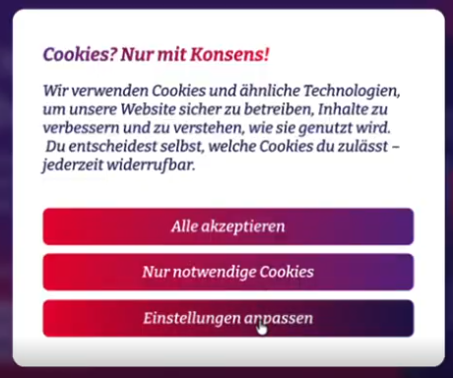
- The text in the first layer of the banner should also include information about:
  - whether individual profiles are created and enriched with data from other websites to form comprehensive usage profiles,
  - whether data is also processed outside the EEA, and
  - how many controllers the data is disclosed to.
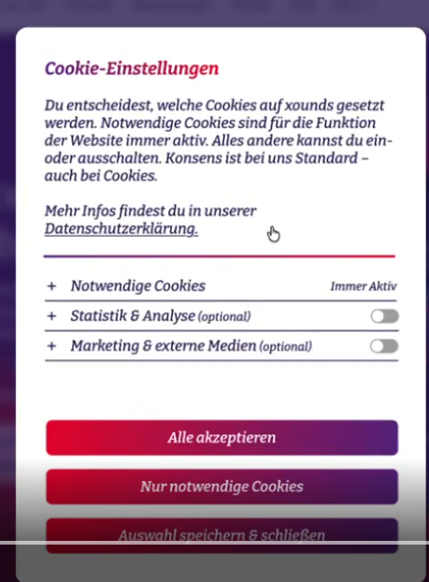
- The banner should also inform users that they have the right to withdraw their consent to optional cookies at any time and indicate how this can be done (see next point).
- In addition to this, you should also make sure that it is as easy to withdraw as to give consent, meaning that there should be an area in your website where users can change their cookie preferences at any time, in an easy way. Revoking consent should not require more steps and search processes than granting it. This can be implemented by including a "cookie setting" section where users have access again to the "Einstellungen anpassen" area to activate or deactivate different types of cookies. Merely referring users to an email address or a contact form is not considered "as easy" to withdraw consent.

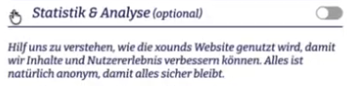
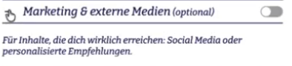
As regards statistical and analysis and marketing cookies, could you please let us know which and how many cookies are set ?

Oct 30, 2025 Kickoff
Company founded this year / only Cornelia and Gabor and a contractor - now they have 3 interns - international team but based in Berlin/Potsdam
They are in a fundraising round and planning on growing → planning on first employees beginning of next year
PRODUCT:
App only in beta at the moment - but they want to add further tracking features in the app and check the data.
Data:
- Email address
- Nickname
- Password
Flow:
- tick on t&c and
- confirm that you are over 18
Now they want to implement further tracking within the app but tbd because they are working on topic of adult entertainment (explicit)
TOPIC= broader intimacy content - adult entertainment content - not sexual sounds but people talking about explicit content.
Issue of age verification - they do not fall within pornographic content but on the edge - at the moment they dont ask for age but might have to → check requirements? Discussion on whether it is the app stores to verify age .
From FEB - they want to ask the people more info (voluntary) to recommend better content for them - ex: gender, sexual orientation, age? etc.
Sign up process:
- Name
- Nickname
- Email address
- Password
- Checkbox:
  - Over 18
  - Accept t&cs
- Mid onboarding users are shown their policy and values - diversity matters etc.
- Once an account is created you can also go to a screen and click on “become a creator” and you are shown a different set of values and once agreed you can become a creator
NB: they do use AI in the app
APP Functionalities
- Users (listeners): Interface kinda like spotify - audio streaming on user side
- Users (creators): users can create/upload content
  - 1st phase → for that people need to speak and say they consent to it - sent to AWS (servers in EU north) and AI system doing speech to text to check if the consent is ok
  - 2nd phase: upload audio or live recording (live not available yet)- also sent to their database and checked by AI with speech to text to check that it is compliant with their guidelines (white/grey/black list) - ai will be built by them not by 3rd parties - only grey list is then double checked by a human + AI check of voice to see if it is the same person consenting and recording (check only against email and nickname) → still in testing - they want it in the future to be done 80% by AI
  - Creators can decide whether they want to share content privately (by choosing another creator to collaborate with by searching for their nickname - “private sharing”) or make it available for all on the platform
AUDIO LIBRARY: Most content is created by users but they also (xounds) have an account and create content
Language: for now only german and english (also because for now they can only understand and check content in those languages) - interface only in english but want to grow
Guidelines for users: are available in the t&c and in the app.
Privacy notice: they created one based on other apps like soundcloud + they included things that are not applied yet → we should review it though
Payment: now for free - now they have only one advertiser a sex toy brand also creating such content that promotes their product at the beginning/end of audio files
UPDATES:
- Now moving whole backend from firebase to AWS - want to launch an update with a freemium model soon
- FREEMIUM MODEL: want to add a Premium version with no ads and also new features first rolled out in the premium (some of them will then also be available in the free version but not all) + FEE: 6.90 per month and 69 per year
- next update they want to make a search functions - hashtags
- Next next the audio file will be revised by ai

Deletion - even if they delete account everything is deleted (3 months retention)
No download option
Admin dashboard:
- They receive notifications of reports/flagged content and they review it manually
- Feedback not public

3rd parties:
- Aws (stockholm nord)
- google (free) for drive and calender
- Hetzner for website
- Only one google account
NEXT STEPS:
- They upload the docs on drive
- We check and map everything on CM + potential other meeting
- Prepare assessment and then deliverables

